|  |
| --- |
|  |
| 新概念 3 册 |
| Lesson19 A very dear cat |

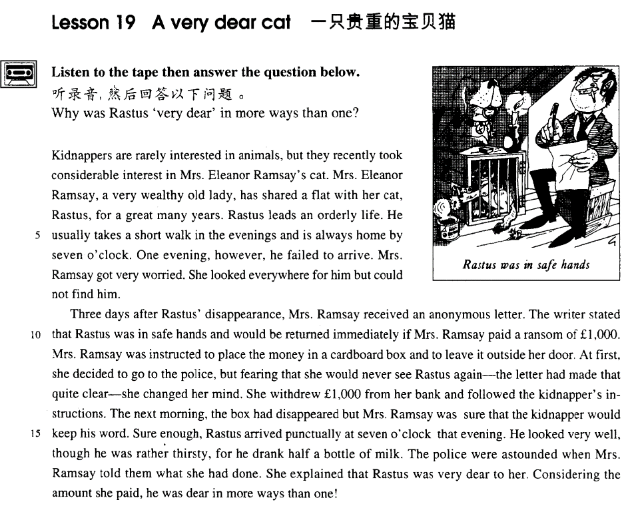

课文

Kidnappers are rarely interested in animals, but they recently took considerable interest in Mrs. Eleanor Ramsay's cat.

绑架者很少对动物感兴趣。最近，绑架者却盯上了埃莉诺.拉姆齐太太的猫。

Mrs. Eleanor Ramsay, a very wealthy old lady, has shared a flat with her cat, Rastus, for a great many years.

埃莉诺.拉姆齐太太是一个非常富有的老妇人，多年来，一直同她养的猫拉斯一起住在一所公寓里。

Rastus leads an orderly life.

拉斯特斯生活很有规律，

He usually takes a short walk in the evenings and is always home by seven o'clock.

傍晚常常出去溜达一会儿，并且总是在7点钟以前回来。

One evening, however, he failed to arrive.

可是，有一天晚上，它出去后再也没回来。

Mrs. Ramsay got very worried.

拉姆齐太太急坏了，

She looked everywhere for him but could not find him.

四处寻找，但没有找着。

Three days after Rastus' disappearance, Mrs. Ramsay received an anonymous letter.

拉斯特斯失踪3天后，拉姆齐太太收到一封匿名信。

The writer stated that Rastus was in safe hands and would be returned immediately if Mrs. Ramsay paid a ransom of ￡1,000.

写信人声称拉斯特斯安然无恙，只要拉姆齐太太愿意支付1,000 英镑赎金，可以立即将猫送还。

Mrs. Ramsay was instructed to place the money in a cardboard box and to leave it outside her door.

他让拉姆齐太太把钱放在一个纸盒里，然后将纸盒放在门口。

At first, she decided to go to the police,

一开始拉姆齐太太打算报告警察，

but fearing that she would never see Rastus again -- the letter had made that quite clear -- she changed her mind.

但又害怕再也见不到拉斯特斯--这点，信上说得十分明白--于是便改变了主意。

She withdrew ￡1000 from her bank and followed the kidnapper's instructions.

她从银行取出1,000 英镑，并照绑架者的要求做了。

The next morning, the box had disappeared but Mrs. Ramsay was sure that the kidnapper would keep his word.

第二天早晨，放钱的盒子不见了。但拉姆齐太太确信绑架者是会履行诺言的。

Sure enough, Rastus arrived punctually at seven o'clock that evening.

果然，当天晚上7点正，拉斯特斯准时回来了。

He looked very well, though he was rather thirsty, for he drank half a bottle of milk.

它看上去一切正常，只是口渴得很，喝了半瓶牛奶。

The police were astounded when Mrs. Ramsay told them what she had done.

拉姆齐太太把她所做的事告诉了警察，警察听后大为吃惊。

She explained that Rastus was very dear to her.

拉姆齐太太解释说她心疼她的猫拉斯特斯。

Considering the amount she paid, he was dear in more ways than one!

想到她所花的那笔钱，她的心疼就具有双重意义了。

词汇讲解

* **dear** [dɪə(r)] adj. 亲爱的；昂贵的
* Dear Mr. Smith,
* my dear daughter
* Come on, dear.

**近义词“亲爱的”:**

**dearest**

**darling**

**honey**

**sugar**

**sweetheart**

**近义词“贵重的、昂贵的”:**

**expensive**

**costly**

**pricy / pricey**

**cost sb. an arm and a leg** （**习语**）使某人出了血本

* **听力真题：**

1. Linda didn't like it.
2. Bill lost it.
3. It was very expensive.
4. It was very small.

M: Did you see the diamond ring Bill gave to Linda?

W: I sure did. It must have **cost him an arm and a leg**.

Q: What does the woman imply about the ring?

Answer: (C) It was very expensive.

**daylight / highway robber**y (**习语**) 大白天抢钱，**昂贵**

* $10 for an orange juice? That's just **daylight robbery**!
* **kidnapper** ['kɪdnæpə(r)] n. 绑架者，绑匪

**kidnapper *n.*** 绑匪；诱拐者

**kidnap** ***vt.*** 绑架；诱拐；拐骗

* The boy was **kidnapped** by a terrorist.

**abduct** ***vt.*** 绑架；诱拐；使外展

**abductor *n.*** 诱拐者

**hijack *vt.*** 抢劫；揩油 ***vi.*** 拦路抢劫 ***n.*** 劫持；威逼；敲诈

**hijacker *n.*** 强盗；抢劫者

**ransom *n.*** 赎金；赎身，赎回 ***vt.*** 赎回，赎；勒索赎金；救赎；得赎金后释放

**hostage *n.*** 人质；抵押品

* **anonymous [ə'nɒnɪməs]** adj. 匿名的
* an anonymous donor(匿名捐助者) / phone call (匿名电话)/ letter(匿名信)

**词根：**

“**onym**” = **name**

**synonym** ***n.*** 同义词；同义字

**antonym** ***n.*** [语] 反义词

**pseudonym** ***n.*** 笔名；假名

**pseudo-science** 伪科学

* O. Henry is the **pseudonym** of William Sydney Porter.
* **withdraw** [wið'drɔ:] v. （从银行）取款

**withdraw … from …** 从…取钱

* I’d like to **withdraw** 2,000 yuan **from** my account.

**deposit … in …** 存钱…

* I’d like to **deposit** 2,000 yuan **in** my account.
* I’d like to **open an account** （开户）.

**current account** 活期账户

**checking account** 活期账户

**deposit account** 定期账户

**savings account** 定期账户

* I’d like to **close my account**（销户） because I’m moving.
* Can I **cash a check**（兑换现金） here?
* What’s the **balance in my account** (余额)?
* What’s the **interest rate**（利率）?
* I’d like to **transfer**（转账） $2,000 **from** my savings account to my checking account.
* Can I **wire** (汇款) some money **to** China from here?
* Is it possible for me to **exchange**（兑换） some British pounds **for** U.S. dollars?
* What’s today’s **exchange rate**（汇率） **for** U.S. dollars?

课文讲解

# Lesson 19 A very dear cat

**双 关 pun**

**dear** 双关语：

treasured / valued 珍视的、珍爱的

expensive / costly 昂贵的

**中文双关：**

* 刘禹锡《竹枝词》杨柳青青江水平 闻郎江上唱歌声 东边日出西边雨 道是无**晴**还有**晴**

**英文双关：**

* Stephen hawking is a **star**（双关） scientist. His expertise is related to cosmology. He is a celebrity.
* More **sun** and **air** for your **son** and heir.
* We must all **hang** together or we shall all **hang** separately.
* ―What do lawyers do when they die? ―**Lie** still.
* The professor tapped on his desk and shouted, “Gentlemen, **order**!” The entire class yelled, “Beer!”

# Kidnappers are rarely interested in animals, but they recently took considerable interest in Mrs. Eleanor Ramsay's cat.

知识点（一）

**表达“几乎不”：**

**rarely**

**seldom**

**almost never**

**hardly ever**

* Rarely （部分倒装，强调句首）are kidnappers interested in animals.

知识点（二）

**表达“产生兴趣…”：**

**take an interest in …** （一般只用单数）

**take no interest in …**

**take little interest in …**

**take considerable interest in …** 产生浓厚的兴趣

**表达“有兴趣…”：**

**have an interest in …**

**have no interest in …**

**have little interest in …**

**have considerable interest in …**

**表达“表现出…兴趣…”：**

**show an interest in …**

**show no interest in …**

**show little interest in …**

**show considerable interest in …**

* **造句**：孩子们很少对历史感兴趣，但是小约翰最近却对古代雕塑产生了浓厚的兴趣。
* Children **are rarely interested in** history, but little John recently **took considerable interest in** ancient sculpture.

# Mrs. Eleanor Ramsay, a very wealthy old lady, has shared a flat with her cat, Rastus, for a great many years.

知识点（一）

**表达“有钱的”：**

**wealthy**

**rich**

**affluent**

**well-off**

**well-to-do**

知识点（二）

**share a house / apartment / flat / room with …** （**用share表达合住，合住的人没有亲属关系，也不是男女朋友**）

* I **shared an apartment with** Kim when I first came to Beijing.

**room with …** （**强调根某人同屋住，尤其强调同宿舍**）

* I **roomed with** him at college.

**live with …** （没有特殊含义）

**cohabit with …** 与某人同居（强调未婚同居）

知识点（三）

**share**：分享分担

* A sorrow **shared** by two is half sorrow; a happiness **shared** by two is double happiness.

**share**：有着共同的

* We **share** an interest in history.
* **造句**：Alfred Bloggs 是 Ellesmere 公司工作的一名垃圾工，他和他的同事 George 合住一个公寓已经很多年了。
* Alfred Bloggs, a dustman for the Ellesmere Corporation, has shared an apartment with his colleague, George, for a great many years.

# Rastus leads an orderly life.

**lead / live a …** life 过着…生活

* **课后习题讲解**

9． Rastus leads a ___C___ life. (1.4)

(a) correct (b) measured (c) regular (d) disciplined

# He usually takes a short walk in the evenings and is always home by seven o'clock.

* I happened to be walking in my garden when I noticed a huge number of snails taking a **stroll**(慢悠悠的散步) on some of my prize plants.

**表达“去散步”：**

**take a walk / stroll**

**have a walk / stroll**

**go for a walk / stroll**

* What do you want to do after breakfast?
* Why don't we **take a walk** down to the river?
* Phoebe: Hey, is Chandler here?
* Joey: No, no he **went for a walk.**

**walk the dog** 遛狗

**stretch one’s legs** （习语）散步

* You can **stretch your legs** on the spacious decks,

# One evening, however, he failed to arrive.

# Mrs. Ramsay got very worried.

# She looked everywhere for him but could not find him.

* … He **could not find** his fifty pence anywhere, …
* She could not find him anywhere.

# Three days after Rastus' disappearance, Mrs. Ramsay received an anonymous letter.

知识点（一）

**表达“几天以后”**

* **Four days after setting out,** while the Titanic was sailing across the icy waters of the North Atlantic, a huge iceberg was suddenly spotted by a look-out.

知识点（二）

**receive sth. from sb.** 从某人收到某事（书面语）

**get sth. from sb.** 从某人收到某事（口语）

**hear from sb.** 收到某人的音信

# The writer stated that Rastus was in safe hands and would be returned immediately *if Mrs. Ramsay paid a ransom of £1,000*.

知识点（一）

**be in safe hands** 被照顾的很安全

* Don’t worry about the children. They **are in safe hands**.
* You can be sure your children **are in good hands**.
* I am afraid that nuclear weapons could **fall into the wrong hands**（落入歹人之手）.

**safe and sound** 安然无恙

* The hostage now is **safe and sound**.

知识点（二）

*a ransom of £1,000*. 1000英镑的赎金

* In 1908 Lord Northcliffe offered **a prize of ￡1,000** （1000英镑的奖金）to the first man who would fly across the English Channel.

**a reward of ￡1,000** 1000英镑的酬金

**a fund of ￡1,000** 1000英镑的基金

**a debt of ￡1,000** 1000英镑的债务

**an investment of ￡1,000** 1000英镑的投资

**a scholarship of ￡1,000** 1000英镑的奖学金

# Mrs. Ramsay was instructed to place the money in a cardboard box and to leave it outside her door.

**instruct sb. to do** 命令某人做某事

* Last year a journalist had been instructed by a well-known magazine to write an article on the president's palace in a new African republic.

# At first, she decided to go to the police, but fearing that she would never see Rastus again―*the letter had made that quite clear*―she changed her mind.

知识点（一）

**go to the police** 报警

* He told him he had better return it or he would **call the police**.

**inform the police** 报警

知识点（二）

**be afraid of ...** 担心

**be afraid that ...** 担心

* … but **afraid of** never **seeing** Rastus again …
* … but **afraid** **that** she would never see Rastus again …

**语法**：形容词一般做定语，补语，表语，一般不做状语

**语法**：副词，介词短语，状语从句，非谓语动词和独立主格一般来做状语

**for fear of ...** 因为担心…会发生

**for fear that ...** 因为担心…会发生

* I didn't turn on the light, **for fear of** waking the baby.
* I didn't turn on the light, **for fear that** it would wake the baby.

**课文写法替换：**

* … but **for fear of** never seeing Rastus again …
* … but **for fear that** she would never see Rastus again …
* **课后习题讲解：**

7 But ___B___ never seeing Rastus again, she changed her mind. (11.12-13)

(a) afraid (b) afraid of (c) for fear (d) afraid for

知识点（三）

**make sth. clear / explicit**  说清楚

* Possible side effects must be **made clear / explicit**.

**clarify** vt.说清楚

* Could you **clarify** your remarks?
* **clarify** one’s position

# She withdrew ￡1000 from her bank and followed the kidnapper's instructions.

# *The next morning*, the box had disappeared but Mrs. Ramsay was sure that the kidnapper would keep his word.

知识点（一）

**the next / following / succeeding morning** 转天早上

**the morning after** 转天早上

知识点（二）

**keep one’s word / promise** 信守诺言（注意单数）

**break one’s word / promise** 没有兑现诺言

* He is **a man of his word** （守信用的人）.
* She is **a woman of her word**（守信用的人）..

# Sure enough, Rastus arrived punctually at seven o'clock that evening.

**sure enough** 果然

* The man took heart and, **sure enough**, on New Year's Eve he was able to hobble along to a party.
* **Sure enough**, a policeman arrived on the scene and politely asked the workmen to go away.

# He looked very well, though he was rather thirsty, for he drank half a bottle of milk.

# The police were astounded when Mrs. Ramsay told them what she had done.

**表达“惊讶”:**

* The **police**（本身就是复数） **were astounded** （大吃一惊）when Mrs. Ramsay told them what she had done.
* When the archaeologists reconstructed the fragments, they **were amazed** （惊讶）to find that the goddess turned out to be a very modern-looking woman.
* When he went outside half an hour later, he **was astonished** （不敢相信）to find that the little black lamb was almost white.
* A short time ago, villagers **were astonished** （不敢相信）to learn that the ghost of Endley had died.

# She explained that Rastus was very dear to her.

# Considering the amount she paid, he was dear in more ways than one!

知识点（一）

**语法：**有一种情况，非谓语动词主语可以和主句主语不统一，就是非谓语本身是一个习语。

* **Strictly speaking**（严格的说）, the whale isn’t a fish.
* **Judging from**（由…判断） his face, he must be ill.
* **To make a long story short**（长话短说）, he wanted money, and tried to get it without working.
* The team has lost the last two games and, **to make matters worse**（事情更糟）, two of its best players are injured.

知识点（二）

**语法**：非谓语动词做习语，看做介词

**considering** ***prep.*** 考虑到；就...而论

**including *prep.*** 包含，包括

**excluding *prep.*** 将……排除在外；不包括……

**concerning *prep.*** 关于；就…而言

**regarding *prep.*** 关于，至于

**respecting *prep.*** 关于；就…而言；鉴于

* China’s foreign policy **concerning** / **regarding** / **respecting** Japan.

知识点（三）

**in more ways than one** 有不止一个方面的含义

* Known to millions, far and wide, for his book ‘A Brief History of Time’, Stephen Hawking is a star scientist **in more ways than one**.

# 总结：

**‘empty nest’ problem** 空巢问题

**‘empty nesters’**空巢者

**‘empty nest’syndrome** 空巢综合征